Ortery Instructions

1. Make sure everything is on
   1. Individual Cameras
   2. Turntable unit.
   3. Camera unit.
2. Make sure lens caps are off.
3. Start software, and if you remembered the above, the cameras should AutoDetect successfully.
   1. If you get a blue screen shortly after the autodetect process, the problem is probably the video drivers. Make sure they are updated.
   2. Make sure all the cameras autodetect. You won’t get any further feedback if one of them doesn’t except that you will end up with the wrong number of pics at the end. If one doesn’t make sure it’s plugged into the rig and click the reload button. A is the bottommost camera.
4. Place the object on the turntable and do your best to center it. Cameras should already be pointed at the center vertical axis.
5. Click the “Capture” button to start, and make sure that 3D is selected for photogrammetry.
6. ISO ought to be as low as possible. I try to set the aperture to be high, ie, a small aperture, and a slower shutterspeed. You can set this individually on all of the cameras via the interface on the computer. 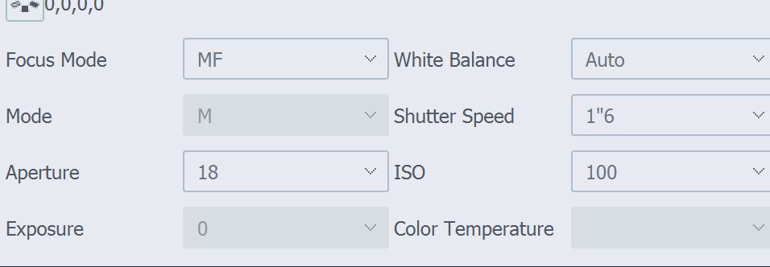
7. Adjust each camera such that the object is in the picture and zoomed properly. Zooming has to be done from the camera itself. You can change the camera in live view with a dropdown on the right side.
8. Now, go through and focus each camera on (programmatic) max zoom in the live view. We can Autofocus if the lens is set to AF. If we want to manual focus, we can set the lens to MF—there’s a button on each one. To autofocus on the computer, go to the view, click the zoom button , and click the AF button.
9. Set the number of pictures to the pictures you want to take per rotation. I like one every 15 degrees, or 24 pictures. More is better, you can prune them later if you would like.
10. Adjust the lighting such that there is as little glare and color difference between the cameras as possible. You can also play with the aperture and shutter speed.
11. When you are happy, click “Snap” to start the photography process.
12. Halfway through, the photography will pause. This is your cue to turn the object over to get the other side. You can use a sandbag to prop it up. Make sure it’s centered again. Note that if the software feels that the object is going out of focus, it will prompt you to refocus before taking a spate of pics. This may adversely affect your results with the photogrammetry, so I’d recommend retrying if you get this.
13. When satisfied, click next to export. Export RAW files, and make sure that it is saving to a new subfolder with the name of your project. I had a hard time with it not actually saving out the RAW files unless I saved it as a subfolder and exported TIFs at the same time, which was odd.